Hello To All The Children Of The World

Chorus: Hello, bonjour, buenos dias
G’day, guten tag, kon'nichiwa
Ciao, salom, dobryĭ denʹ
Hello to all the children of the world.

We live in different places
From all around the world
We speak in many different ways
There something might be different
We’re children just the same
And we all like to sing and play

Chorus: …

There are children in the deserts,
And children in the towns
And children who live down by the sea
If we could meet each other
To laugh, and sing, and play
Then what good friends we all could be.

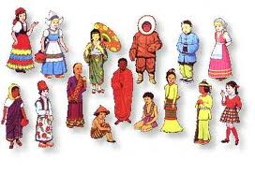
Chorus: …

Four Hugs A Day

Chorus: Four Hugs a day, that's the minimum,
Four Hugs a day, not the maximum.
Four Hugs a day, that's the minimum,
Four Hugs a day, not the maximum.

Step one, look them right in the eye
Step two, nose to nose
Step three, reach your arms
Step four, you can't do any harm with

Chorus: …

Don't forget your Mama and Papa,
Your Grandma, your Grandpa,
And all your friends too,
Brothers and Sisters, Aunts and Uncles,
And don't forget your teachers too,
We need:
One, two, three and four, we need:
One, two, three and four, we need:

Chorus: …
Don’t forget to give four hugs today!
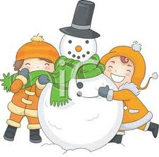

Mix:
Let It Snow & Winter Wonderland

The weather outside is frightful,
But the fire is so delightful,
And since we've no place to go,
Let It Snow! Let It Snow! Let It Snow!

It doesn't show signs of stopping,
And I've bought some corn for popping,
The lights are turned way down low,
Let It Snow! Let It Snow! Let It Snow!

Sleigh bells ring, are you listening,
In the lane, snow is glistening
A beautiful sight, we're happy tonight.
Walking in a winter wonderland.

Gone away is the bluebird,
Here to stay is a new bird
He sings a love song, as we go along,
Walking in a winter wonderland.

Santa Claus is coming to town!

You better watch out
You better not cry
Better not pout
I'm telling you why
Santa Claus is coming to town!

He's making a list
And checking it twice;
Gonna find out who's naughty or nice
Santa Claus is coming to town!
He sees you when you're sleeping
He knows when you're awake
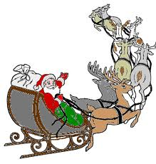
He knows if you've been bad or good
So be good for goodness sake!

You better watch out!
You better not cry
Better not pout
I'm telling you why
Santa Claus is coming to town!

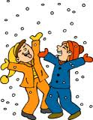
The Ha! Ha! Holiday Song

Let’s put some Ha! Ha! Ha! In the holidays
and La! La! Laugh with joy.
Let’s put some Ha! Ha! Ha! In the holidays
and make it fun for every girl and boy.

Just put some giggle in your wiggle and flap your feet,
Have some fun with someone you’re about to meet.
Let’s put some Ha! Ha! Ha! In the holidays
and have a Ha! Ha! Happy New Year!

